Medium post
Tau: A new class of boardgame
Innovation usually begins not by adding to what already exists but by removing an established rule or convention. Ｗhat do most abstract strategy games, like checkers, chess, and Go, have in common?
- They usually have multiple pieces per player that must be coordinated.
- Piece shapes and imagery are usually symbolic eg. you can have Simpsons characters as your chess pieces without changing the nature of the game.
- Pieces move in straight lines or are placed along straight lines
- Pieces are moved or placed in discrete intervals. You cannot make a fraction of a move.

What would a game look like that defies these three assumptions?

Tau is a two-player game where each player has a single three-legged piece on a circular board. The object of the game is to push the opponent’s piece off the edge of the board using your own piece. Each turn one leg is kept in place while the other two are moved around in an arc. This circular movement is continuous, and while there are limits on how far you can move, you can choose where to stop at any point before this limit.
When pieces collide they move in regular, but intrinsically complex ways, based on the geometry and weight distribution of the piece. This is a game that embraces subtlety and geometry over algorithms, that rewards spatial thinking and precision.

What does this new class of boardgame have that others don't?

All competitive board games are essentially a competition to see who best grapples with complexity. Existing games broadly fit into one of the following two categories of complexity.

Complicated: Chess uses a complicated assortment of simple pieces and rules to create complex tactical problems.

Emergent: Go has a fundamental simplicity to its rules and pieces, it is at a large scale that emergent patterns and phenomena create complexity.

Tau introduces a third category.
Irreducible: when two fighters grapple, their moves can not be recorded and repeated precisely, they are not analysing long sequences of moves, they are dealing with an opponent that is fundamentally complicated and using a different style of analysis to make decisions.
Tau distils grappling down to a simple set of rules, removes physical strength and dexterity and yet retains some of this irreducible complexity of interaction and movement.

The story of Tau

History:

In late 2018 an ad for a Judo board game caught my attention. There are a plethora of games that represent battles between two small armies: chess, Chinese Chess, checker, and tabletop battle games like Warhammer come to mind, but I couldn't think of one that meaningfully represents 1 to 1 combat. I was curious to see what such a game would look like. When I looked into the game it seemed to be a judo themed deck-building card game where the underlying mechanics had little to do with martial arts.
Feeling underwhelmed I started to wonder what a grappling themed game would be if Grappling was a central mechanic rather than a theme.

My first idea was to have two pieces that consist of legs and hip joints. They would play on a grid and take turns moving one leg at a time. The first person to trip the opponent would win. I quickly realised two legs were going to be too unstable, so I switched to three

Picture of version 1

This game proved too difficult to make small movements without accidentally knocking pieces over. When I showed a friend I noticed him ignoring the hip joints and just rotating the whole pieces around a single foot. This gave me the idea of switching away from Judo style tripping to a game about controlling space and distance in the spirit of boxing ringcraft, Sumo or Greco roman wrestling.

I knew the game needed some limits on movement, but given the circular movement it would be impossible to make a grid-style board like chess where every move is equal distance and discrete.

I started experimenting with using lines to mark regions and limiting each turn to a set number of line crossings. I quickly realised straight lines would not work well with circular movement, and decided to make all patterns circular.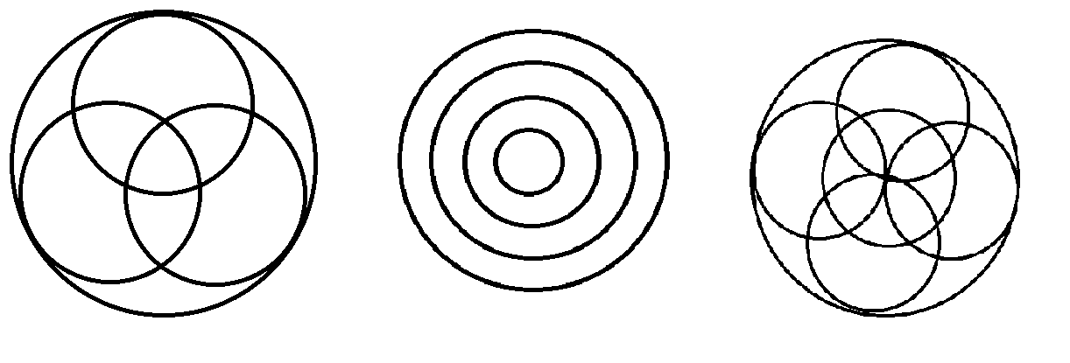

It took a lot of experimenting to realise that most of the lines needed to be closer to the edge, with the centre more open in order to make the game dynamic and balanced in all regions.
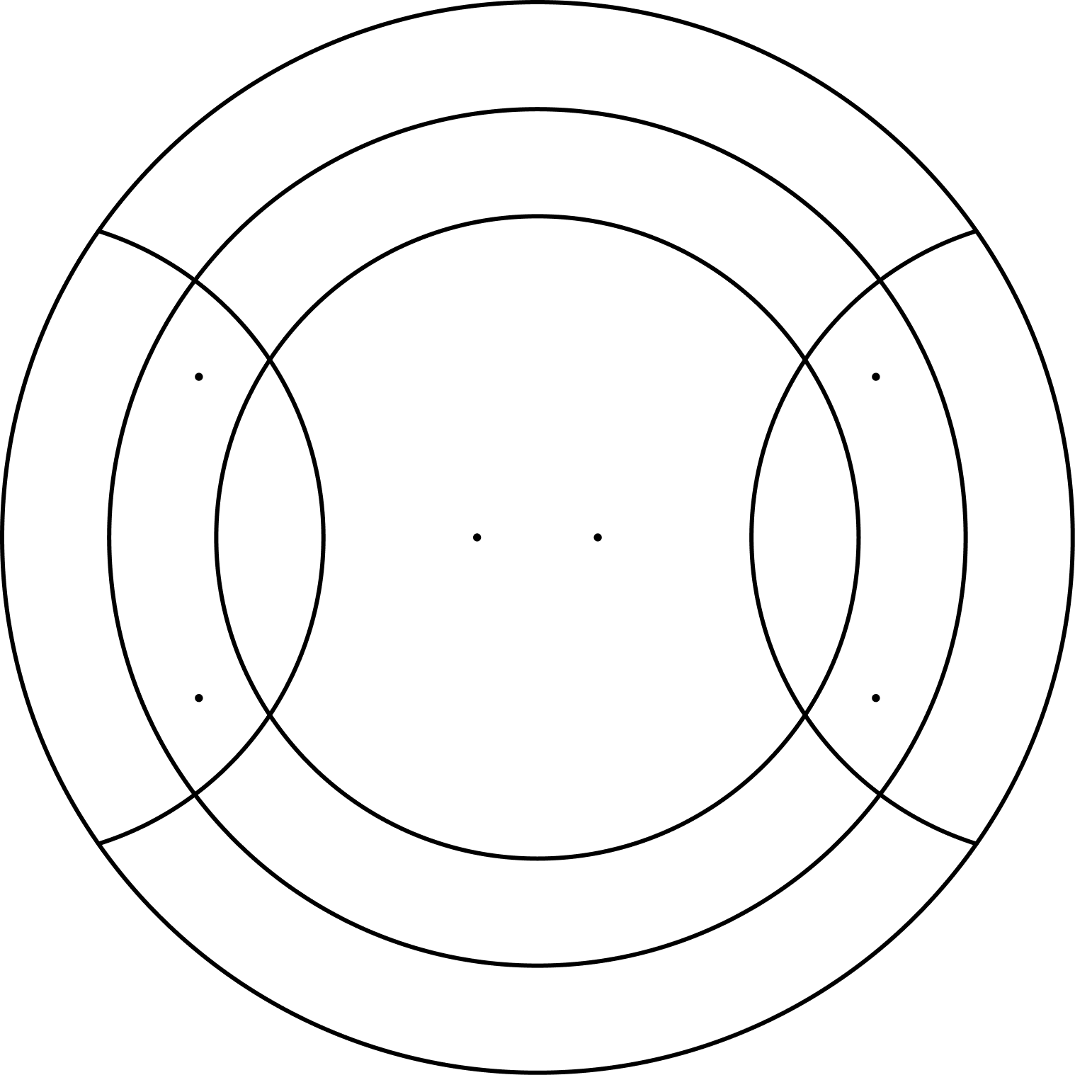

After settling on the final board pattern I experimented with different shapes for the tripod pieces until it hit me, this whole game is about circles, so the pieces should be made of circles too!

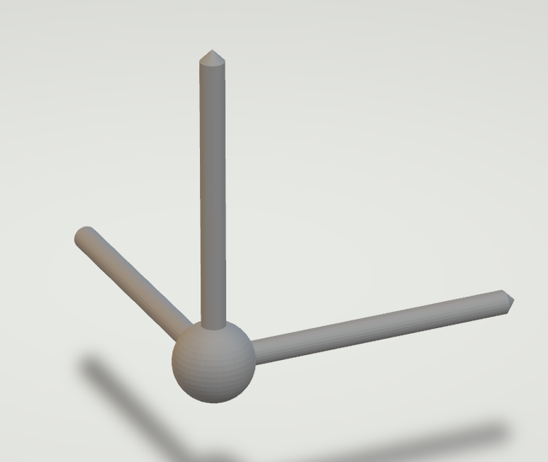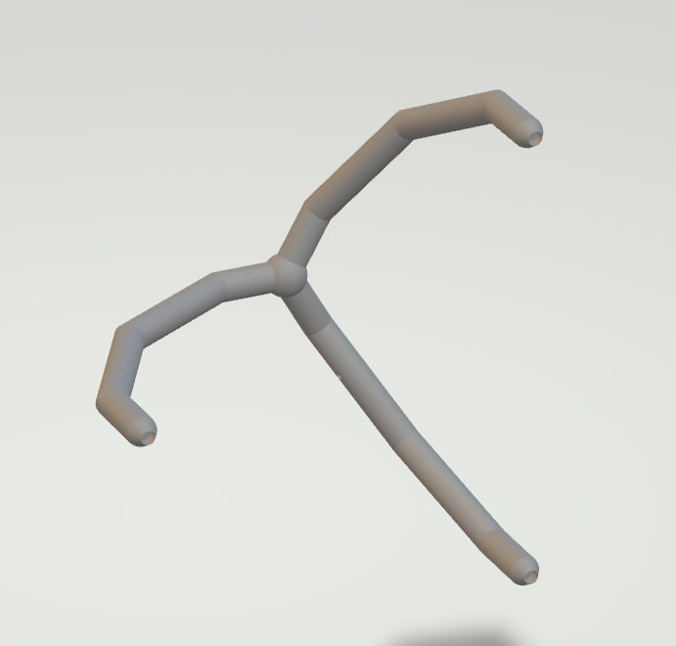
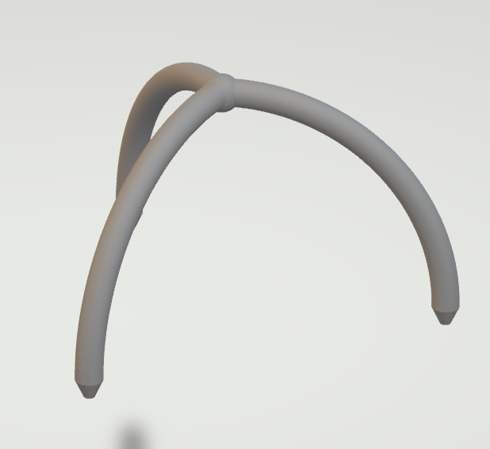

Rational:

Many abstract strategy games are symbolic representations of battle or war: Games like Chess focus on protecting a leader in a local battle, games like Go look at a larger war campaign and focus on the allocation of resources to many small battles and the connections between them. Tau aims to do something novel, to represent one on one combat.
Martial arts are extremely complex, so this game specifically focuses on one element; controlling space. In striking arts, controlling the centre of the Ring/Cage, avoiding the edges, and cutting off your oponent is an important skill called ringcraft. https://thumbs.gfycat.com/IndolentDetailedGalapagospenguin-mobile.mp4
In many Grappling arts, points are awarded for pushing an opponent out of bounds.
In Tau players win by pushing their opponent's piece off the edge of the board. Like boxing or kickboxing, it is important to cut your opponent off and limit their ability to get away from the edge. Like wrestling or Sumo, there is an important balance between pressuring your opponent, without overextending yourself and being vulnerable to being redirected off the edge like an
UWATE-NAGE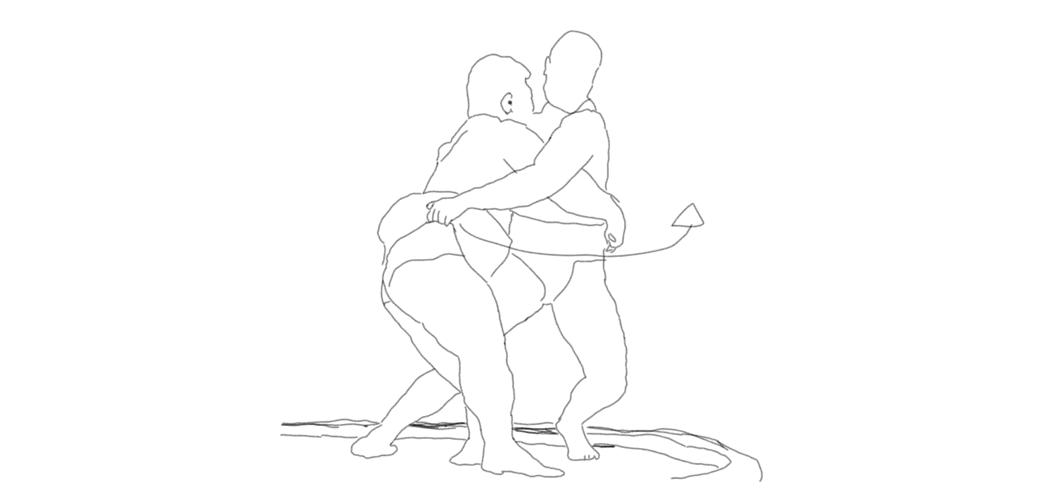 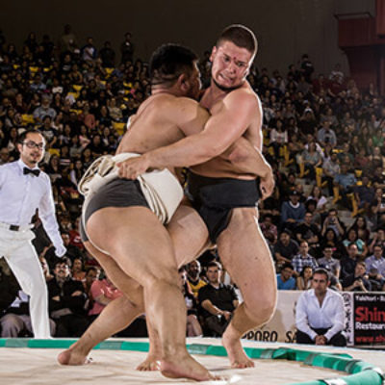 or SOTO-GAKE 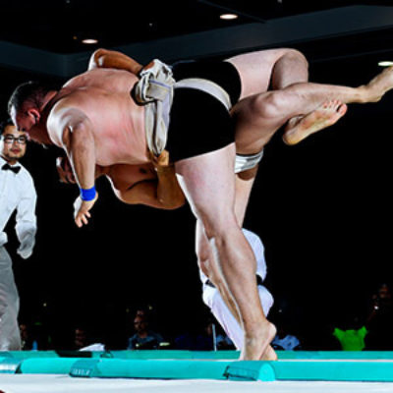

Insert picture of similar thing with board game here

In Tau, each turn a player moves their piece so that one foot remains stationary and two moves. The moving feet will trace an arc that, if continued, would make a circle. Movement is limited to crossing one line per turn, however, unlike virtually all other abstract strategy games there is an infinite number of final positions you can land on. Movement is continuous so a player can stop at any point before crossing two lines. This means that a game has the infinite variability of something like snooker, but can be replayed consistently like chess.

Move-in circles
Control space
Push opponent
Attack
Infinite possibilities like pool/darts
Predictable like chess

Rules:

- The starting position is pictured below. All three feet sitting on a dot
- Red moves first
- Each turn a player may move their piece by holding one of their pieces feet still and rotating the other two feet around this point.
- You can only move your piece in one direction per turn
- A piece may only make one line crossing per turn, and must stop before a second line.
- If a piece begins a turn with a foot on a line, leaving that line does not count as a line crossing
- You may use your piece to push your opponents piece. This must be done slowly and smoothly so that the pieces move together. Be careful not to touch your opponents piece with your hand
- You win when one or more of your opponents feet are pushed off the edge.

One sentence slogan

A martial arts game of angles

A game of geometry and violence

A two-player game of tactics and angles

Geometric combat

A two-player strategy game of

Instagram posts

Moving in circles

Think of any abstract strategy game. How do pieces move?
Chess: straight lines (knights do a funny L shape)
Checkers: diagnoal lines
Go: pieces line up in straight lines.
etc etc

Tau is different. In Tau every move is circular.
There are no straight lines in movement, in the design of the pieces, or in the board itself.

Go off grid

Chess and checkers have 64 squares. A piece can only move onto one of these squares. There are billions of possible games, but there are only a small number of possible moves.
A 19x19 Go board has 361 positions. in
Tau movement is continuous. you can stop here or here or here. or any where in between

Subtle decisions

Strategy games can be great for developing a certain kind of analytical thinking. If I go here, they go there, then I go here. It’s thinking how simple pieces fit together in sequence. This kind of thinking will help you manage a warehouse where you move this box to this shelf and that box to this shelf and so on.
This is different from the type of thinking used in natural environments and martial arts. In martial arts combatants rarely think so many steps ahead. That doesn’t mean combat is without analysis, rather they make subtle decisions about distance, angles and timing to set up opportunities for attack
In Tau two moves can be subtly different but have real consequences. Take position A and position B for example. They look very similar, but after the oponent moves watch how they diverge.

No repeats/Jo battle

You can't get stuck in a loop

Complexity
All competitive board games are essentially a competition to see who best grapples with complexity. I see existing games as fitting into one of the following two categories of complexity

Complicated: Chess uses a complicated assortment of simple pieces and rules to create complex tactical problems.

Emergent: Go has a fundamental simplicity to its rules and pieces, it is at a large scale that emergent patterns and phenomena create complexity.

Tau introduces a third category.
Irreducible: when two fighters grapple, their moves can not be recorded and repeated precisely, they are not analysing long sequences of moves, they are dealing with an opponent that is fundamentally complicated and using a different style of analysis to make decisions.
Tau distils grappling down to a simple set of rules, removes physical strength and dexterity and yet retains this irreducible complexity of interaction and movement.

Redirection
Matador aikido Bagua

Counter attack

THEME

Go-money/war
Chess-battle
Tau-fight

Infinite possibilities

Feints and fakes

Dexterity game for the undexterous
H

Grappling
Weight and leverage

